**Mutually Conflicting Requirements**

Mamdouh Zayed

Colorado State University Global

CSC505: Principles of Software Development

Dr. Pubali Banerjee

April 22, 2024

**Mutually Conflicting Requirements**

To address the issue of mutually conflicting requirements among stakeholders in software development, one effective approach is to employ a facilitated workshop where stakeholders can openly discuss their requirements, concerns, and priorities. This process pattern aims to foster collaboration and consensus-building among stakeholders to resolve conflicts and reach a shared understanding of the software specifications.

**Stakeholder Engagement:**

Invite stakeholders to participate in the workshop, ensuring representation from all relevant departments and user groups. Communicate the importance of collaboration and the goal of resolving conflicting requirements to achieve a successful software outcome.

**Conflict Resolution:**

1. Identify areas of disagreement or conflicting requirements among stakeholders.

2. Facilitate constructive dialogue to understand the underlying reasons for conflicting perspectives.

3. Encourage stakeholders to focus on shared objectives and explore compromises or alternative solutions that address diverse needs.

**Communication Diagram:**

The communication diagram represents the interaction between stakeholders and the system while collecting and processing their requirements.

**Stakeholders**: Represent each stakeholder involved in the project (User 1, User 2, Developer, Manager).

**System:** Represents the system responsible for collecting and processing requirements.

**Messages**:

Stakeholder -> System: Represents the stakeholder providing their requirements to the system. This can be done through various methods like interviews, surveys, or written documents.

System -> Stakeholder: Represents the system providing or presenting options to the stakeholder.

Stakeholder1 -> Stakeholder2: Represents communication between stakeholders to discuss and negotiate their requirements.

System -> Requirements List: Represents the system storing the collected requirements.

By following these guidelines, I can effectively address conflicting requirements and ensure that my software development project meets the needs of all stakeholders.

This Python script prompts the user to input the stakeholders and the number of communication pathways in my diagram and analyzes the specified diagram to determine the stakeholders involved and the number of communication pathways.

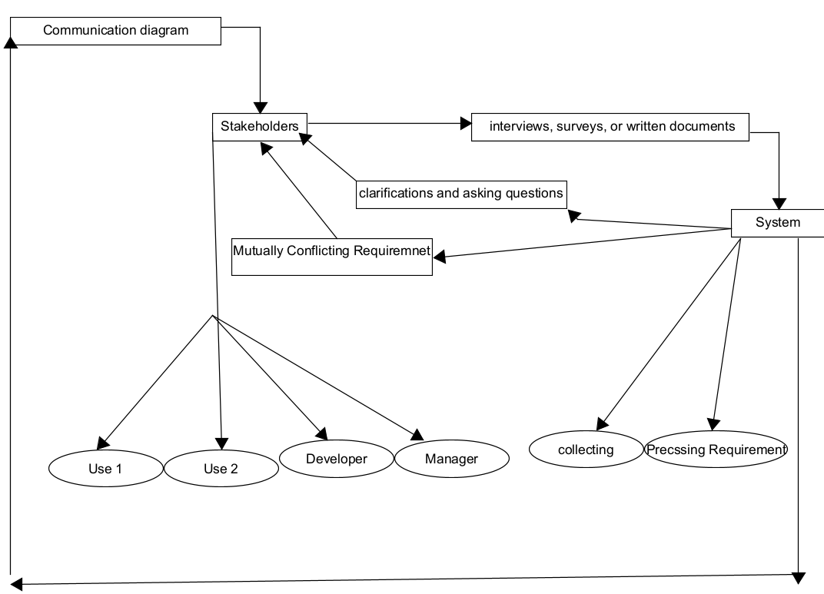

**This is the output of the diagram:**

**References**

Arthur M. Langer. (2016). Guide to Software Development: Designing and Managing the Life Cycle: Vol. Second edition. Springer.

Jill Clarke. (2020). Software Developer. BCS, The Chartered Institute for IT.

Pressman, R., & Maxim, B. (n.d.). Software Engineering. software-engineering-a-practitioners-approach-9nbsped-9781260548006-1259872971.